TASK 9.1

BASIC ADMINISTRATION OF LINUX OPERATING SYSTEMS


Jesús Ballesta Bernabé 1ºDAM

1. User administration

1. The management of users and groups can be performed directly through the command prompt. The most important commands for user and group management are shown below. Complete the table:

Command | Description
 | Users Management
adduser | Is used to add a new user to the system
deluser | Is used to delete a user account from the system
useradd | Is user to create a new user account , similar to adduser
userdel | Is used to delete a user account from the system
usermod | Is used to modify user account attributes
passwd | Used to change a user’s password and update their own passwords
chage | Allows modify user password expiration information
id | Displays user and group information for a specified or the current user
who | Displays information about users who are currently logged into the system
users | Displays a list of usernames of users who are currently logged into the system
su | It allows you to change the current user context to another user
sudo | Allows users to execute commands with the privileges of another user
 | Groups Management
groups | Is used to display the groups that the current user is a member of
addgroup | Is used to add a new group to the system
delgroup | Is used to delete a group from the system
groupadd | Is used to create a new group on the system
groupdel | Is used to delete a group from the system
groupmod | Is used to modify group attributes on the system
newgrp | Allows start a new shell session with a different primary group

2. For most of the following commands, more information can be obtained with the system help. Get detailed information on the use and operation of the commands listed in the table above.

adduser
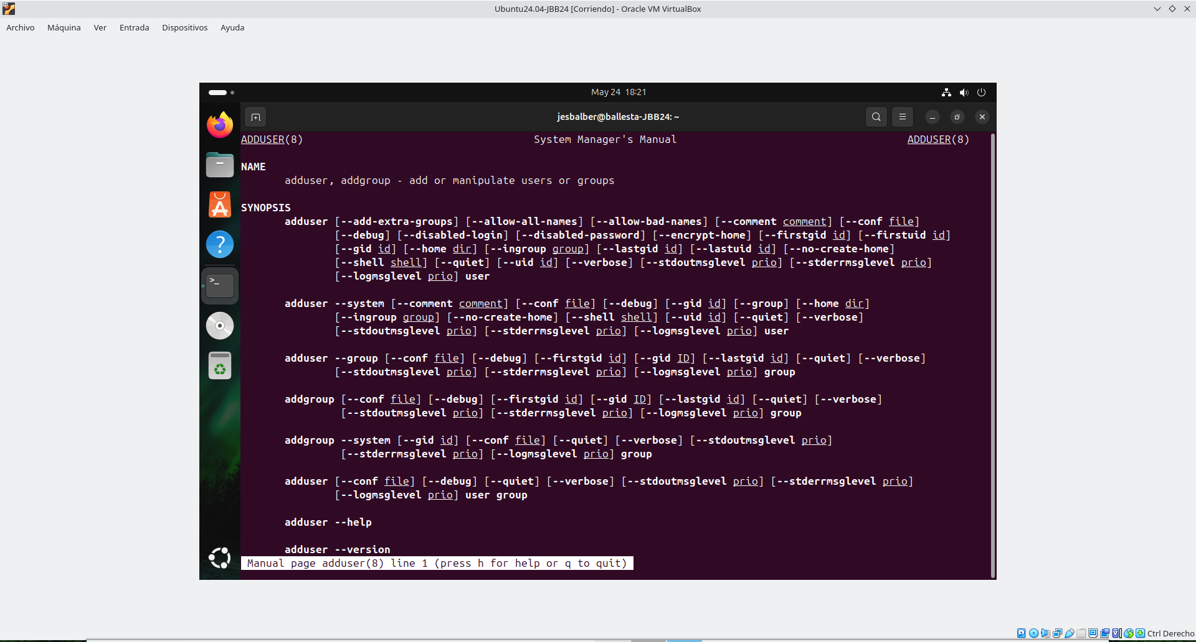

deluser
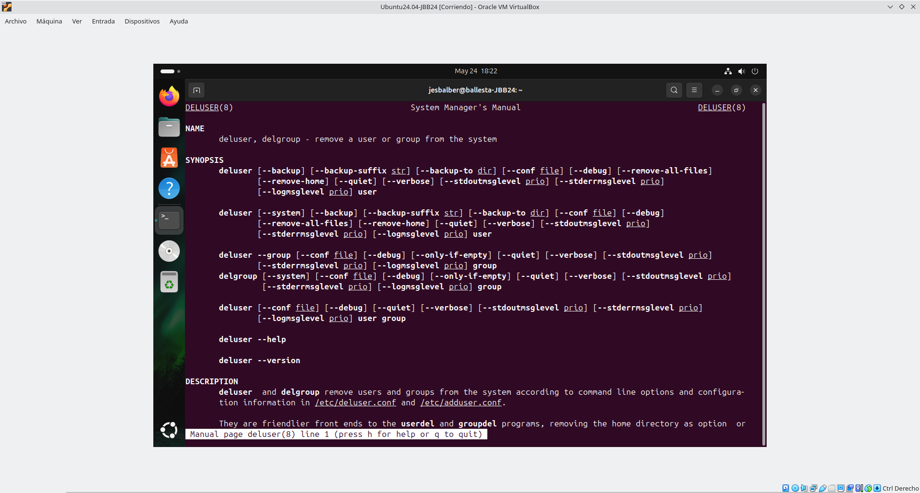
useradd
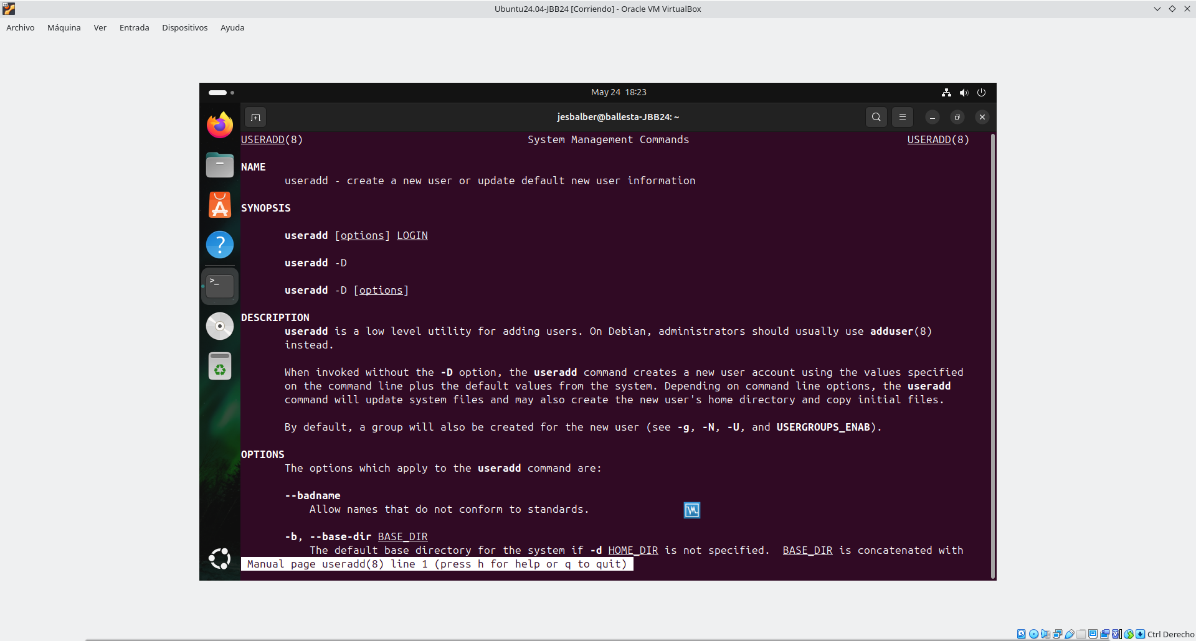

userdel
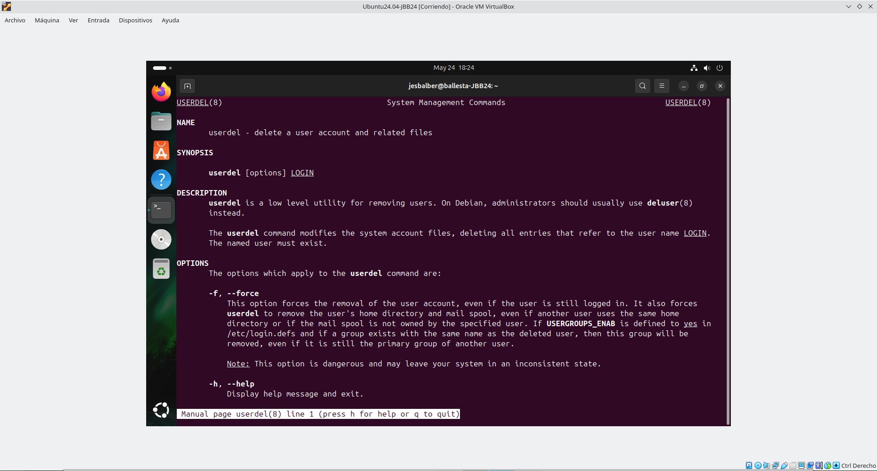
usermod
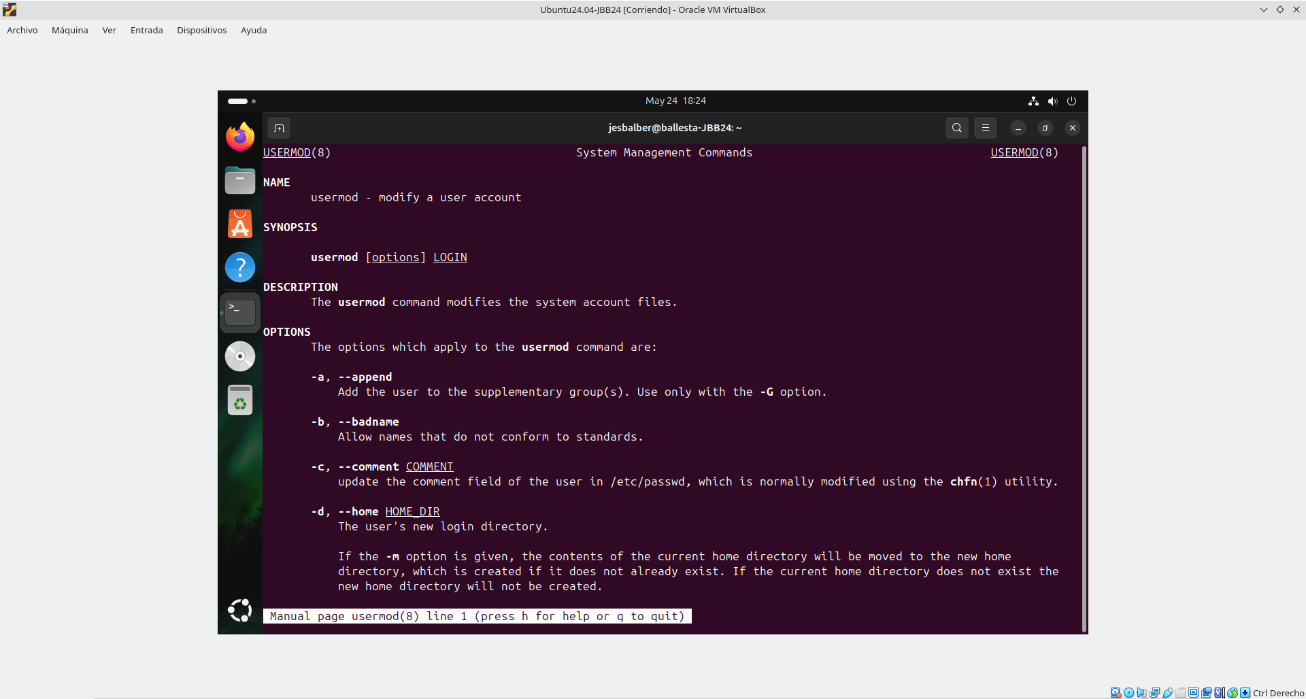

passwd
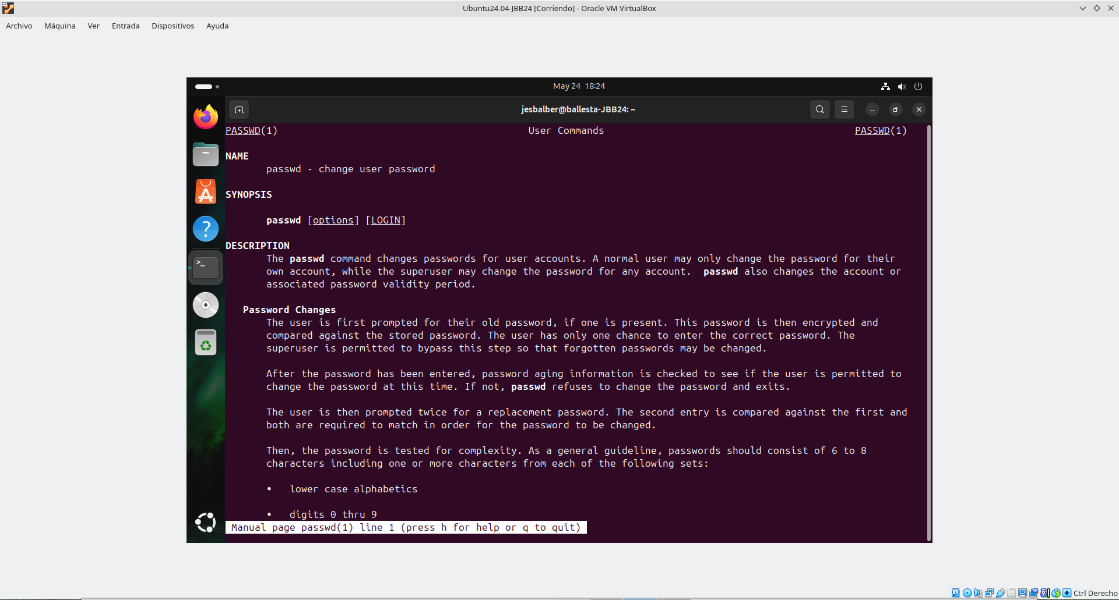
chage
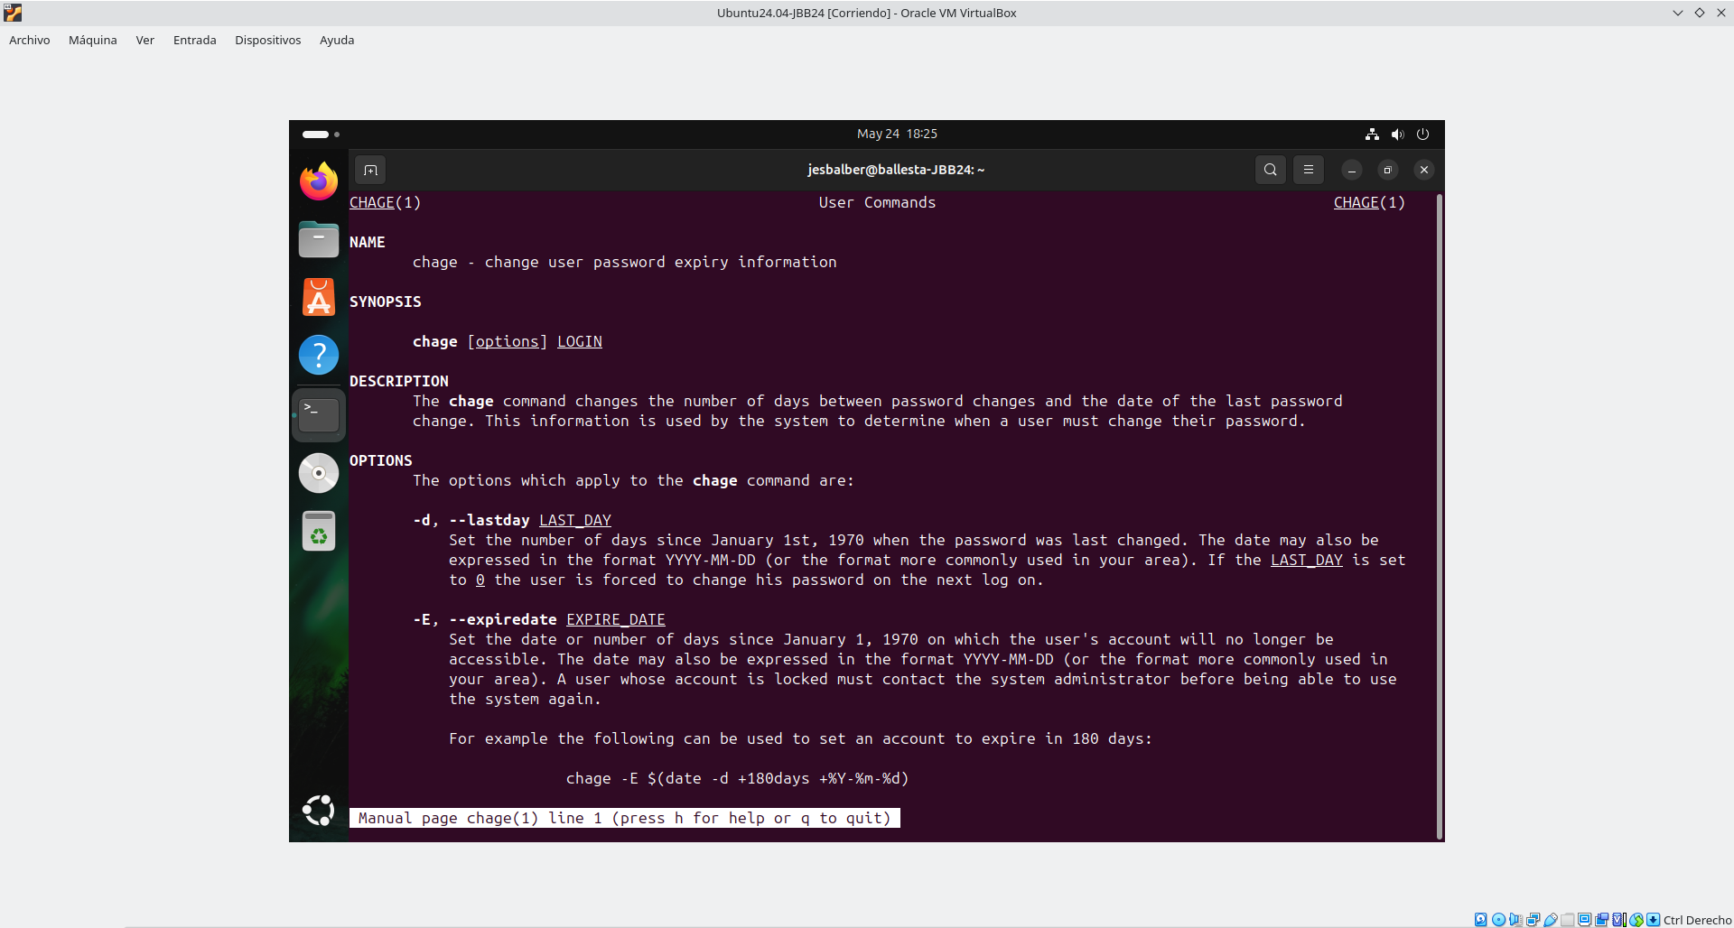

id
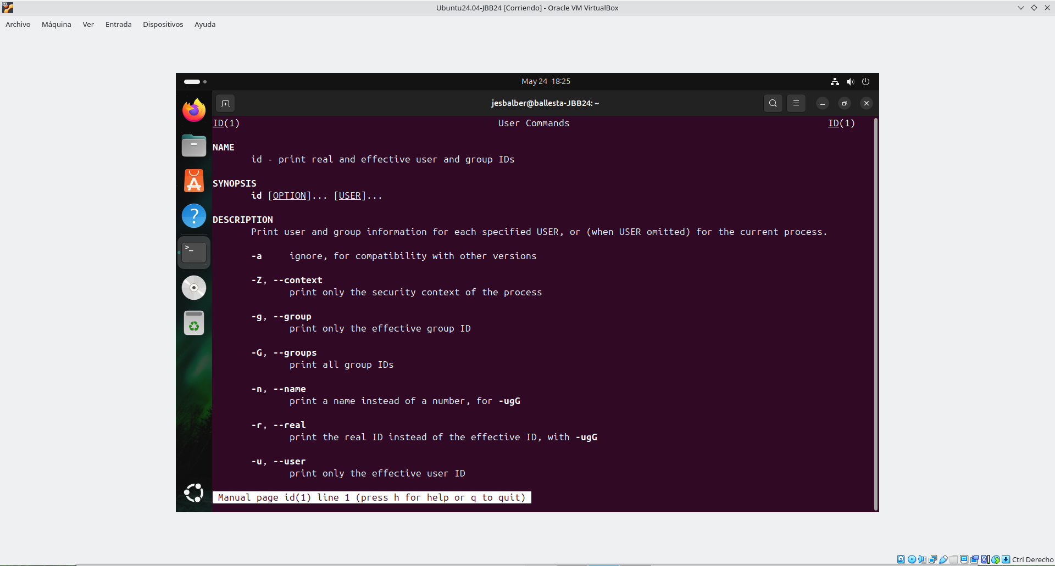
who
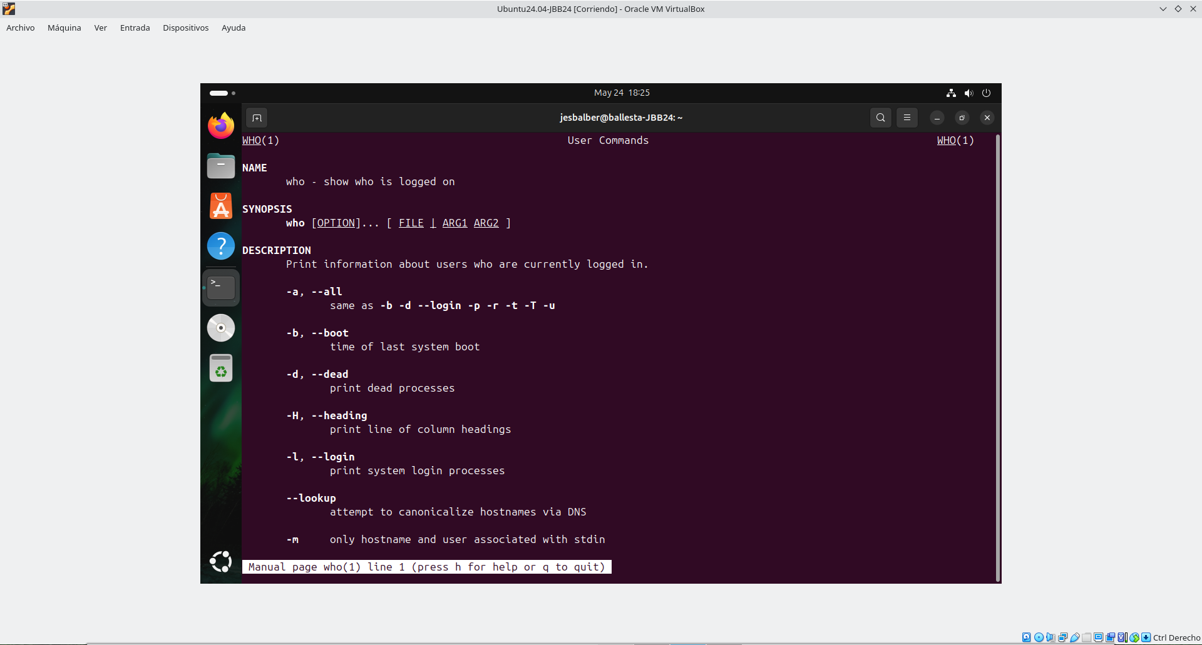

users
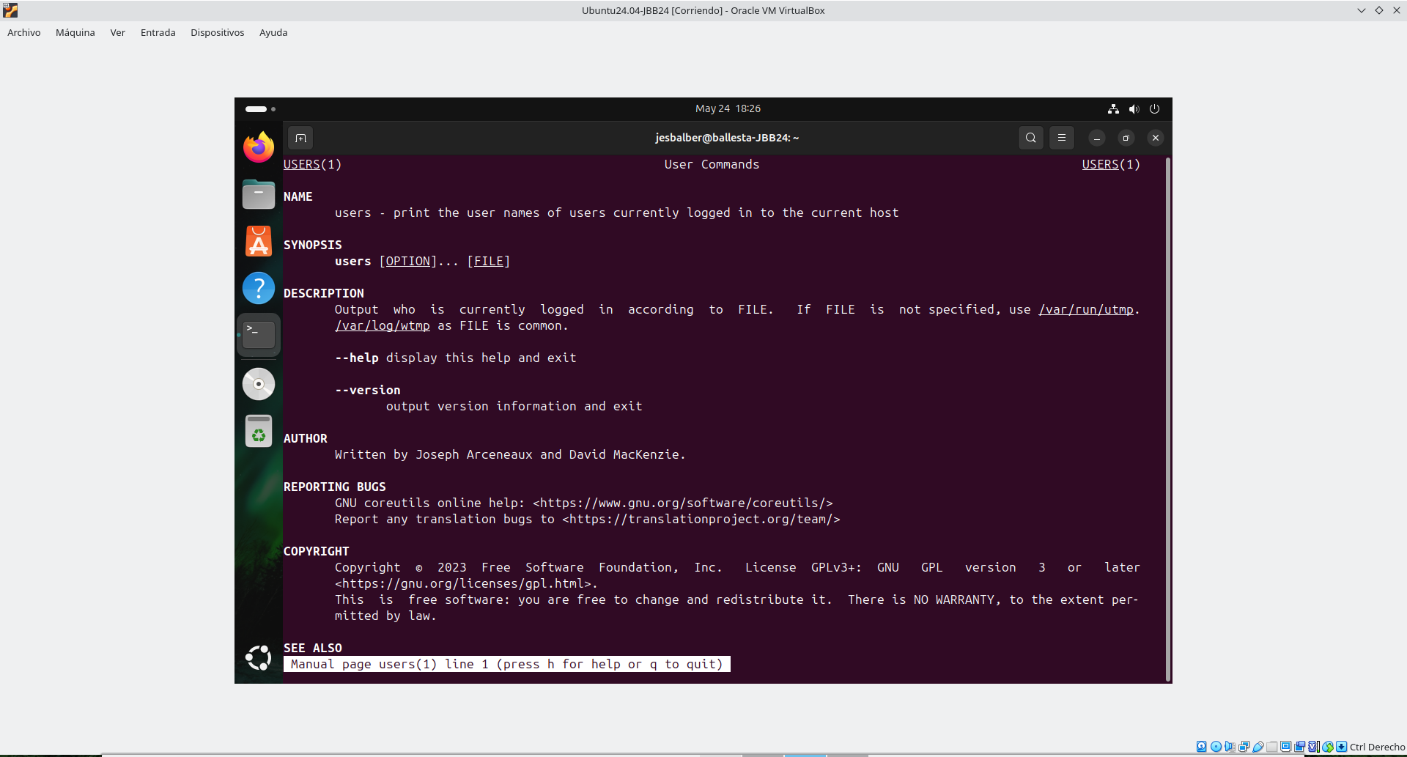

su
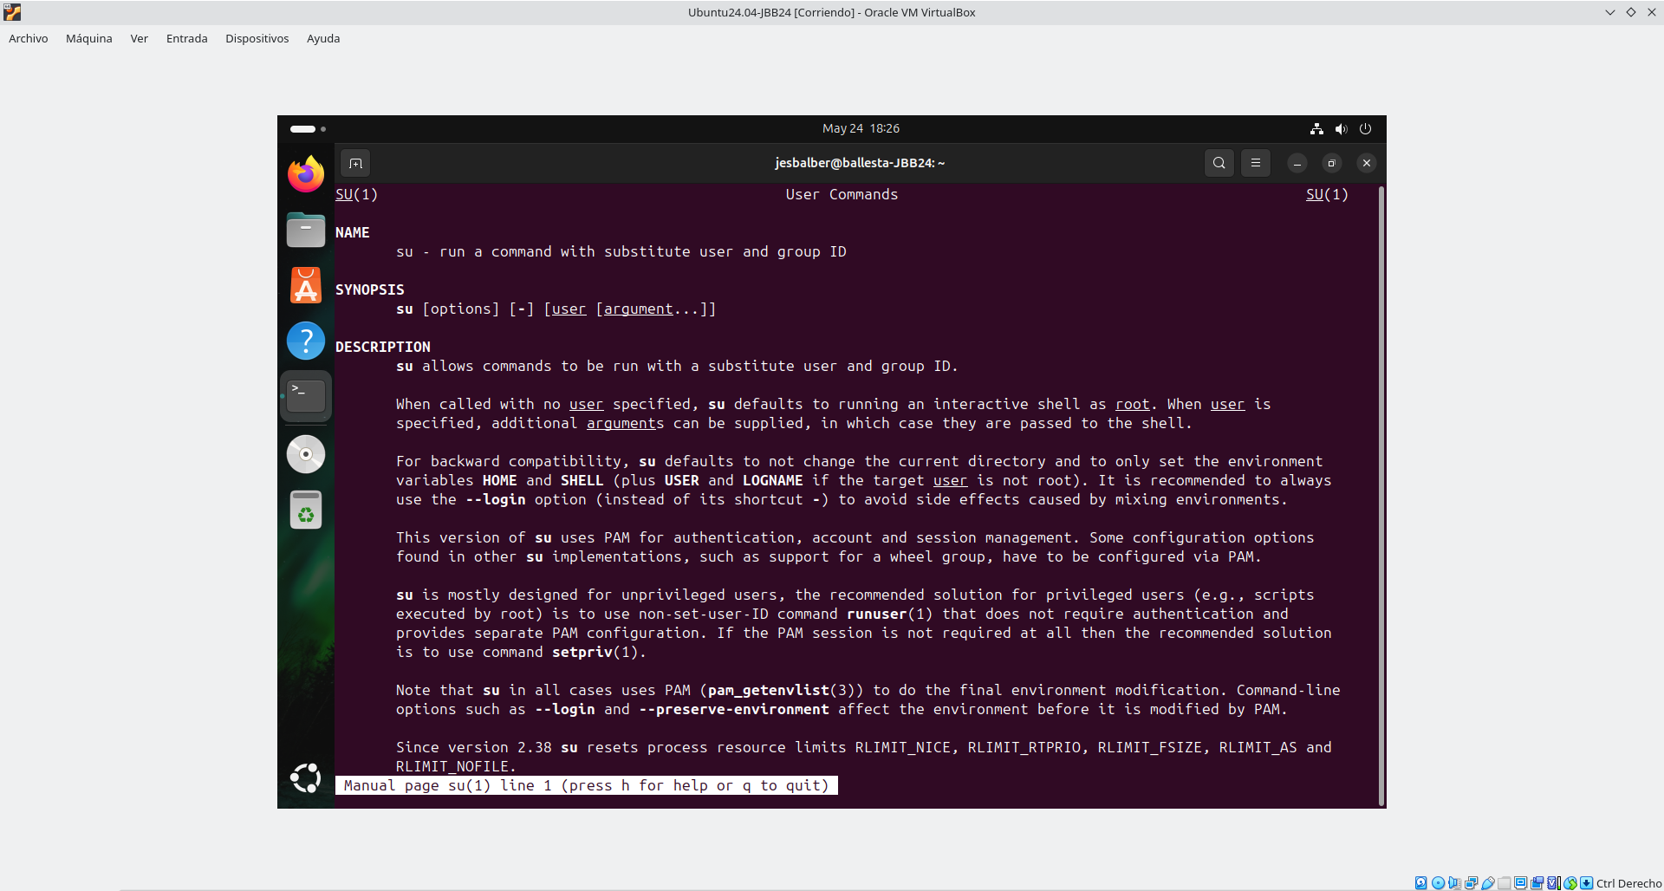

sudo
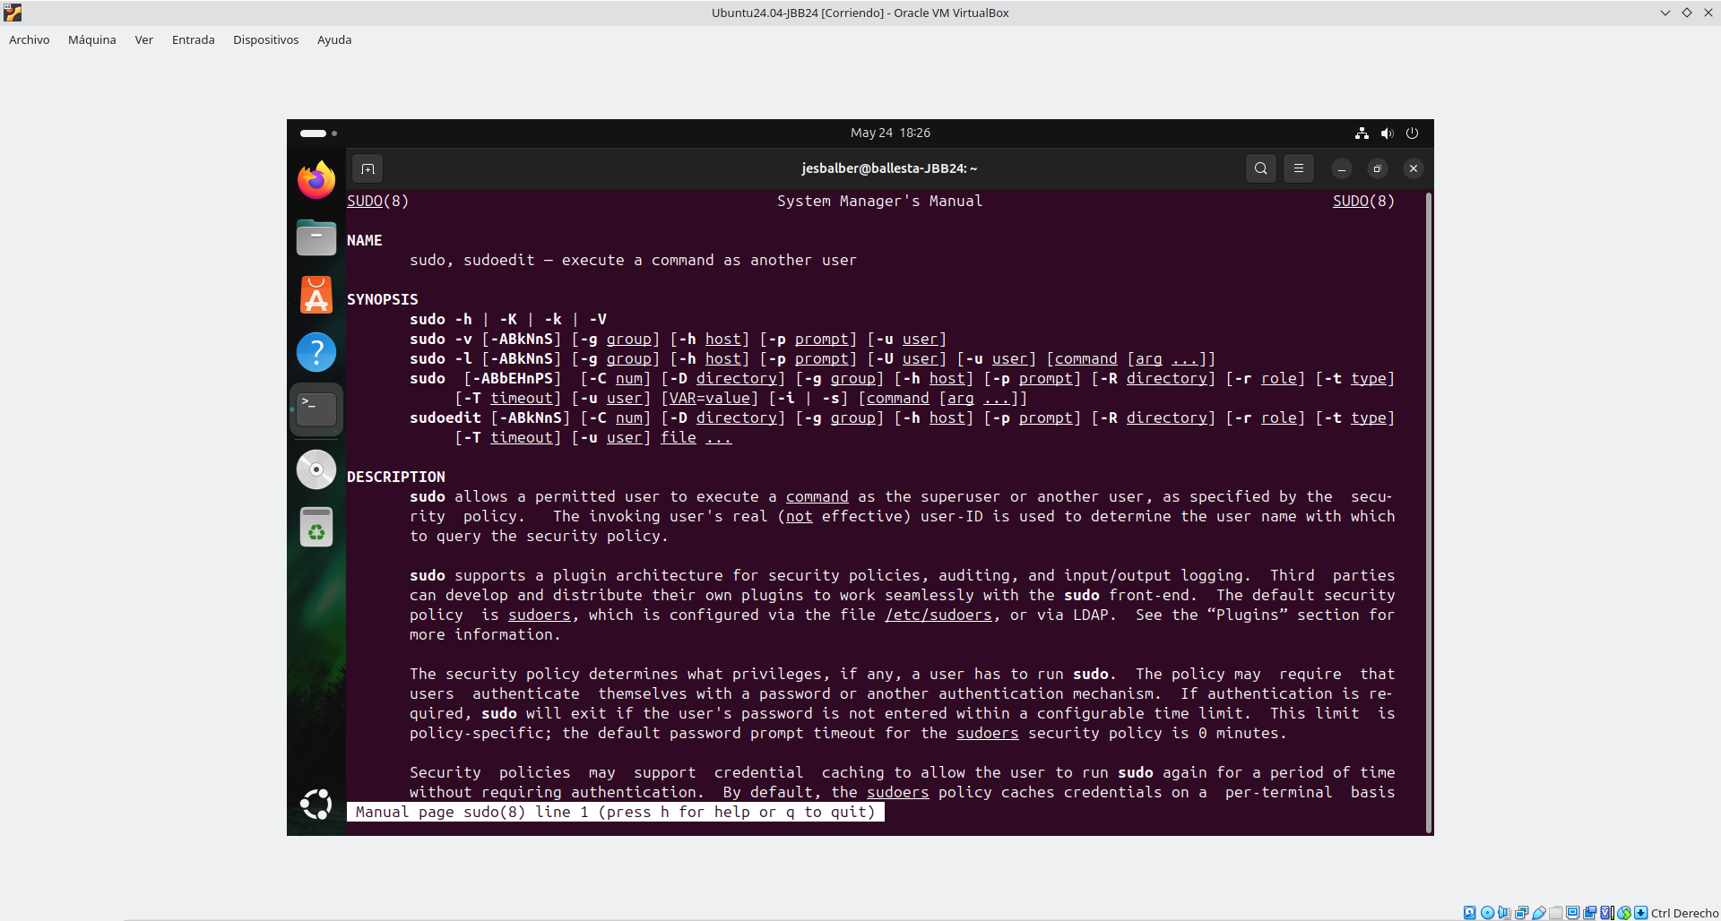
groups
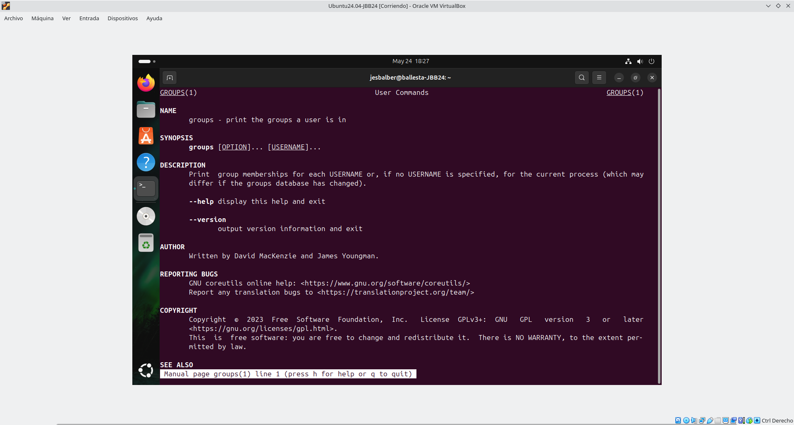

addgroup
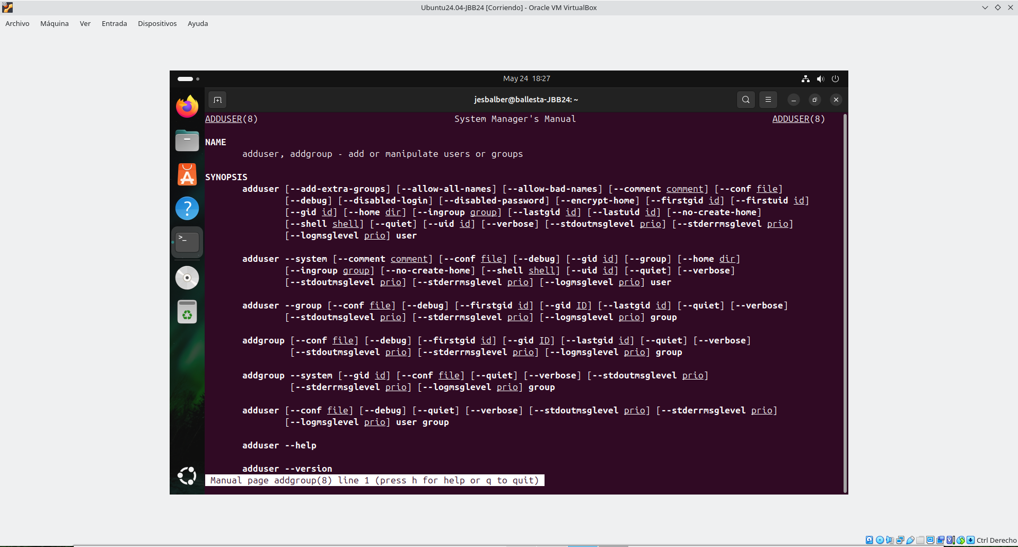
delgroup
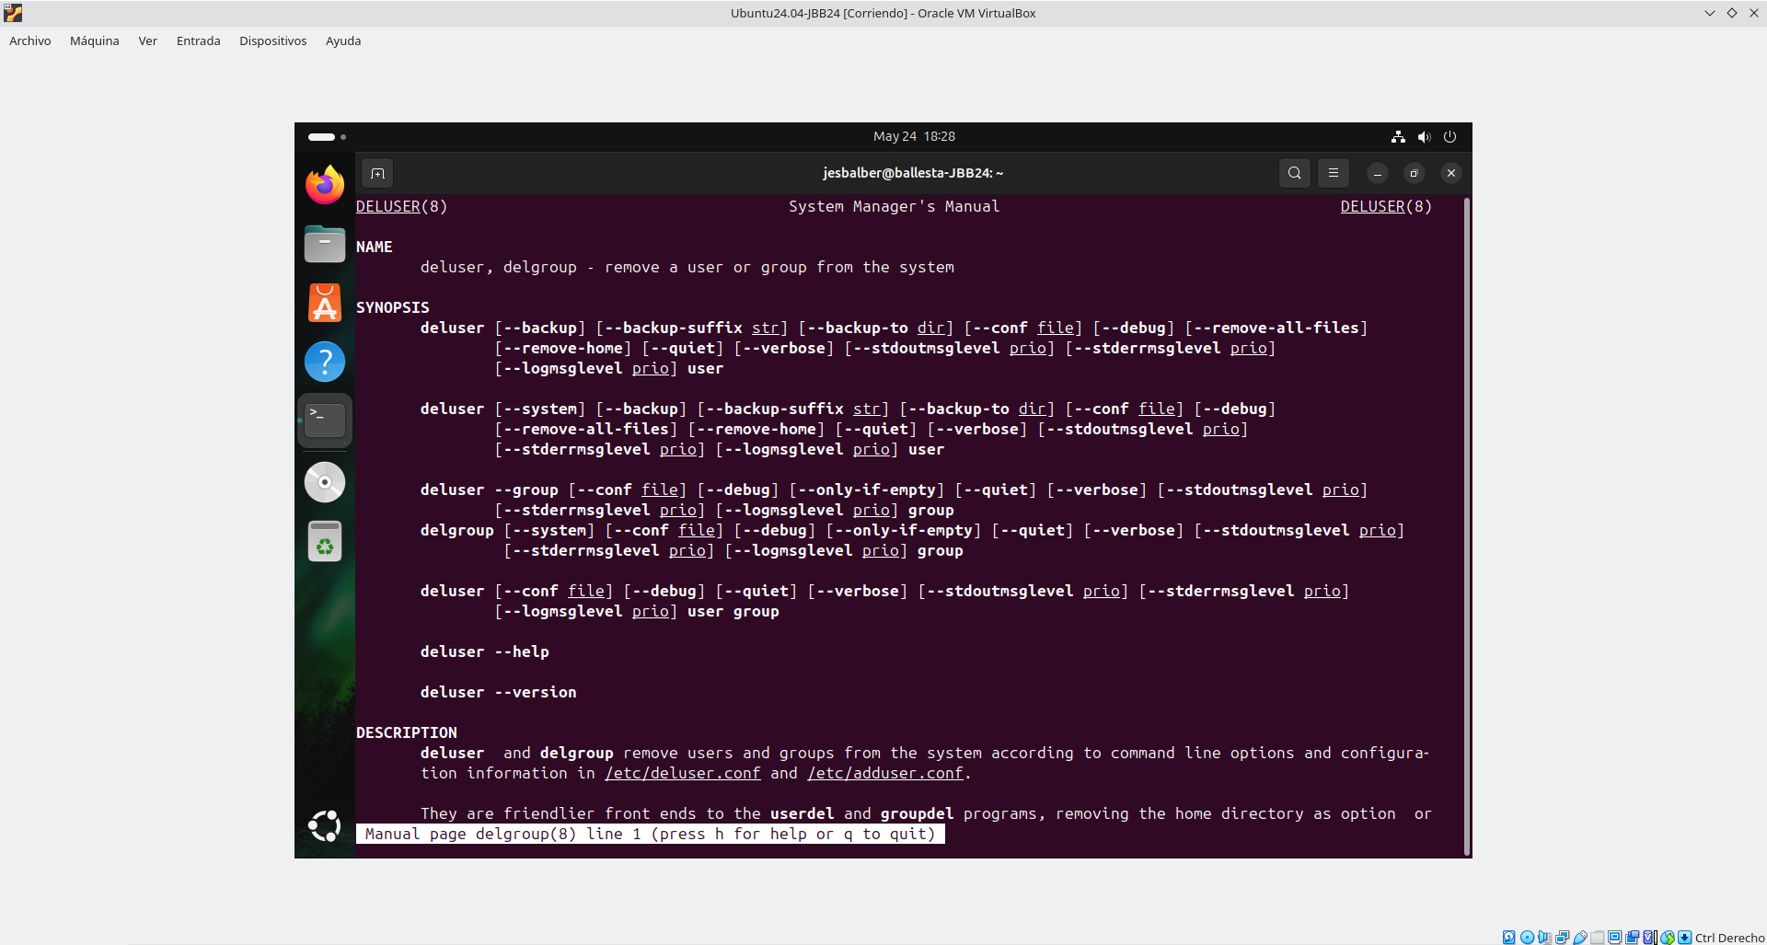

groupadd
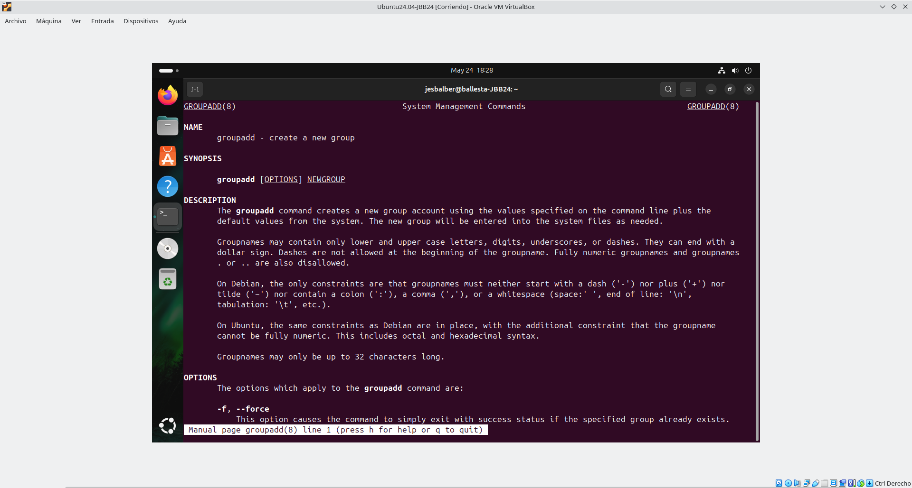
groupdel

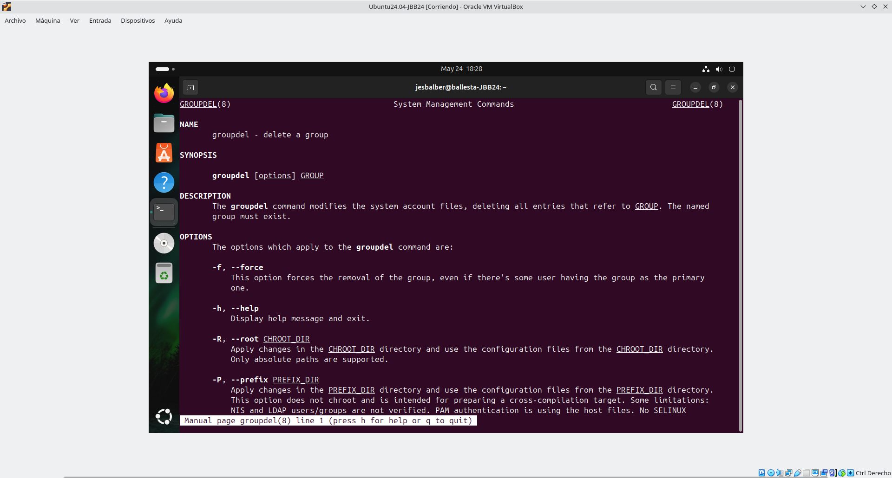

groupmod:
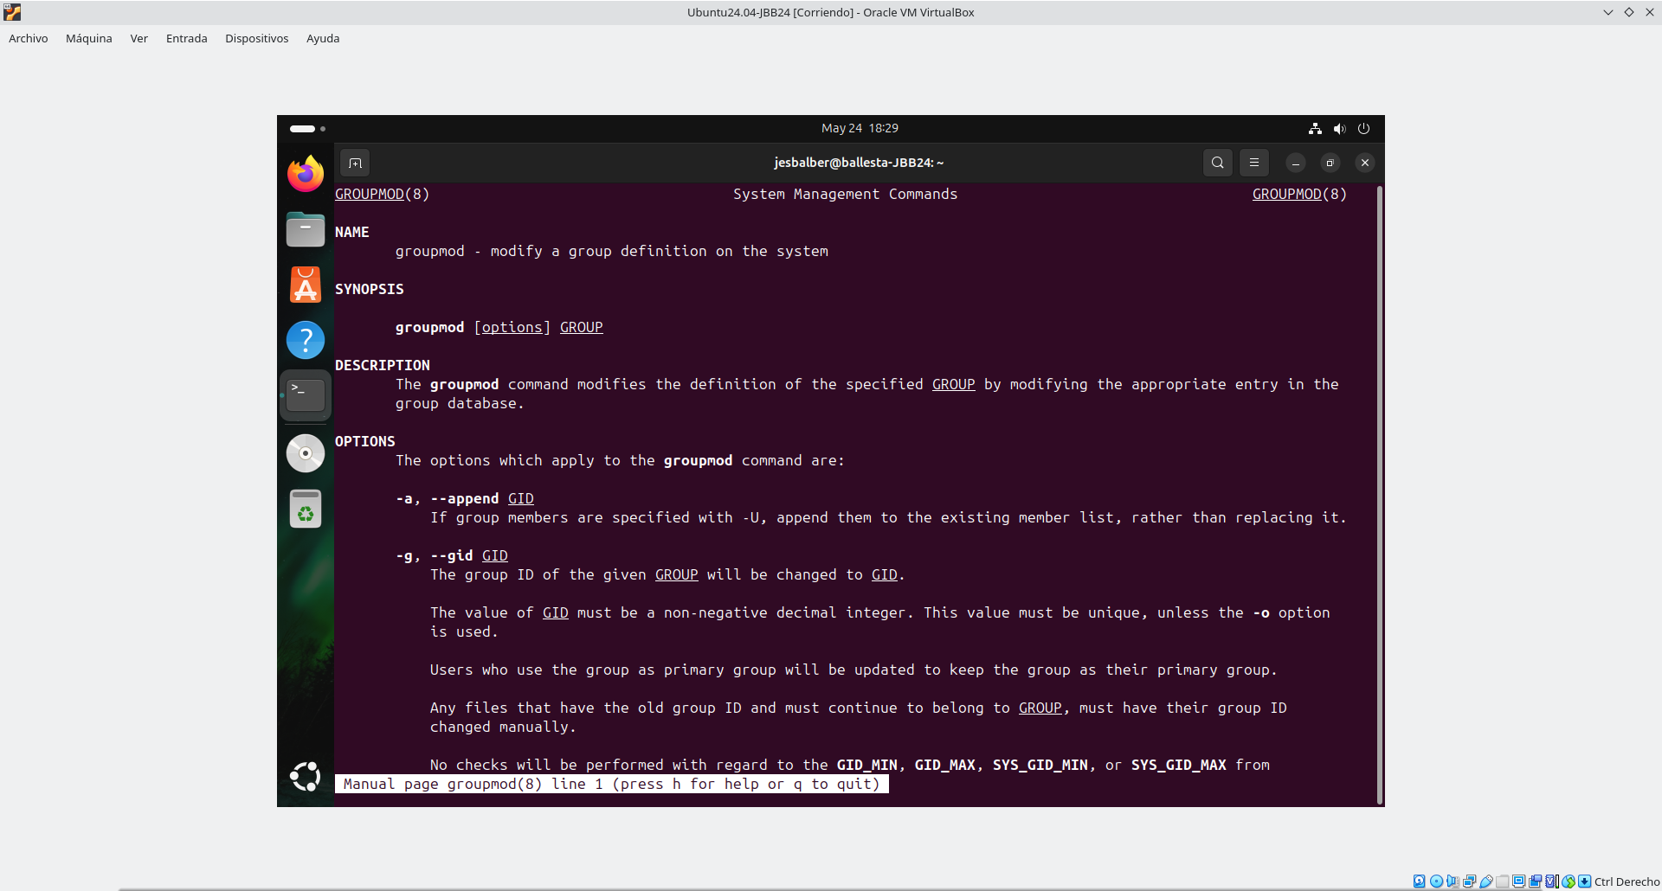
newgrp

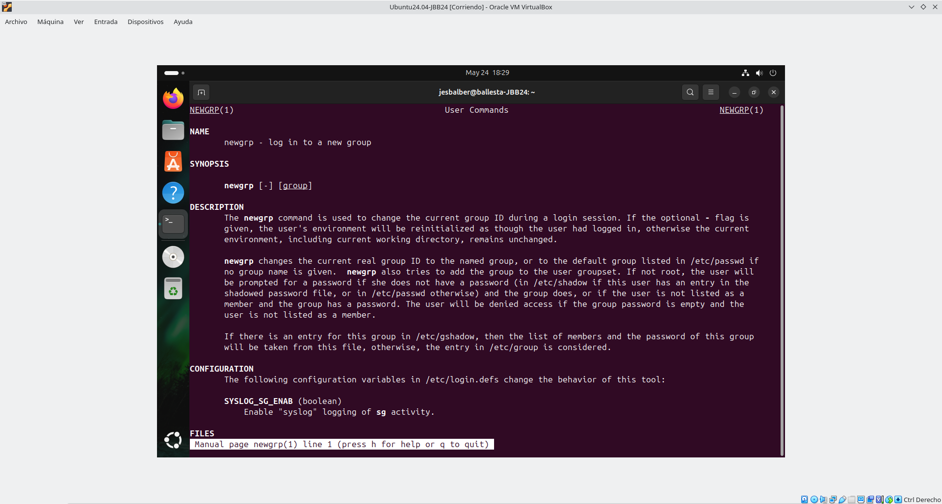

3. By using command adduser create users: blackpanter-<codId> with UID (User Identifier) 2000+<nºPC>, spiderman-<codId> with UID 3000+<nºPC> and home /home/s1-<codId>, and thor-<codId> with UID 4000+<nºPC> and shell /bin/sh.
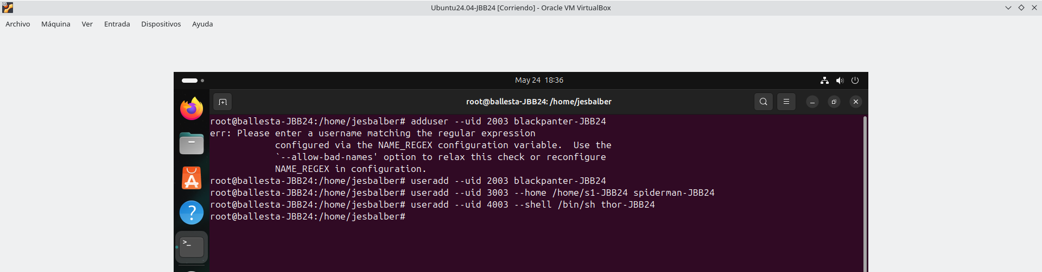

4. Run a command to view last 3 users created. In other words, show only last 3 lines of user configuration file.
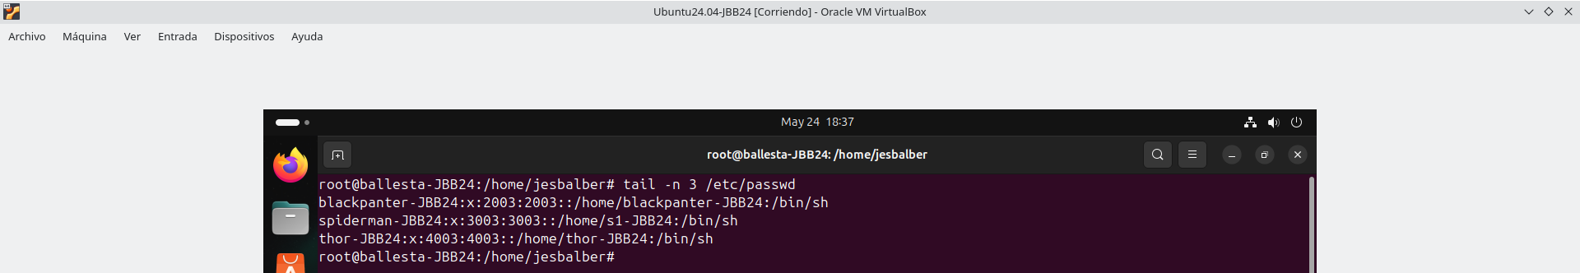

5. Run a command to show last and first 10+<nºPC> groups created. Use group configuration file.
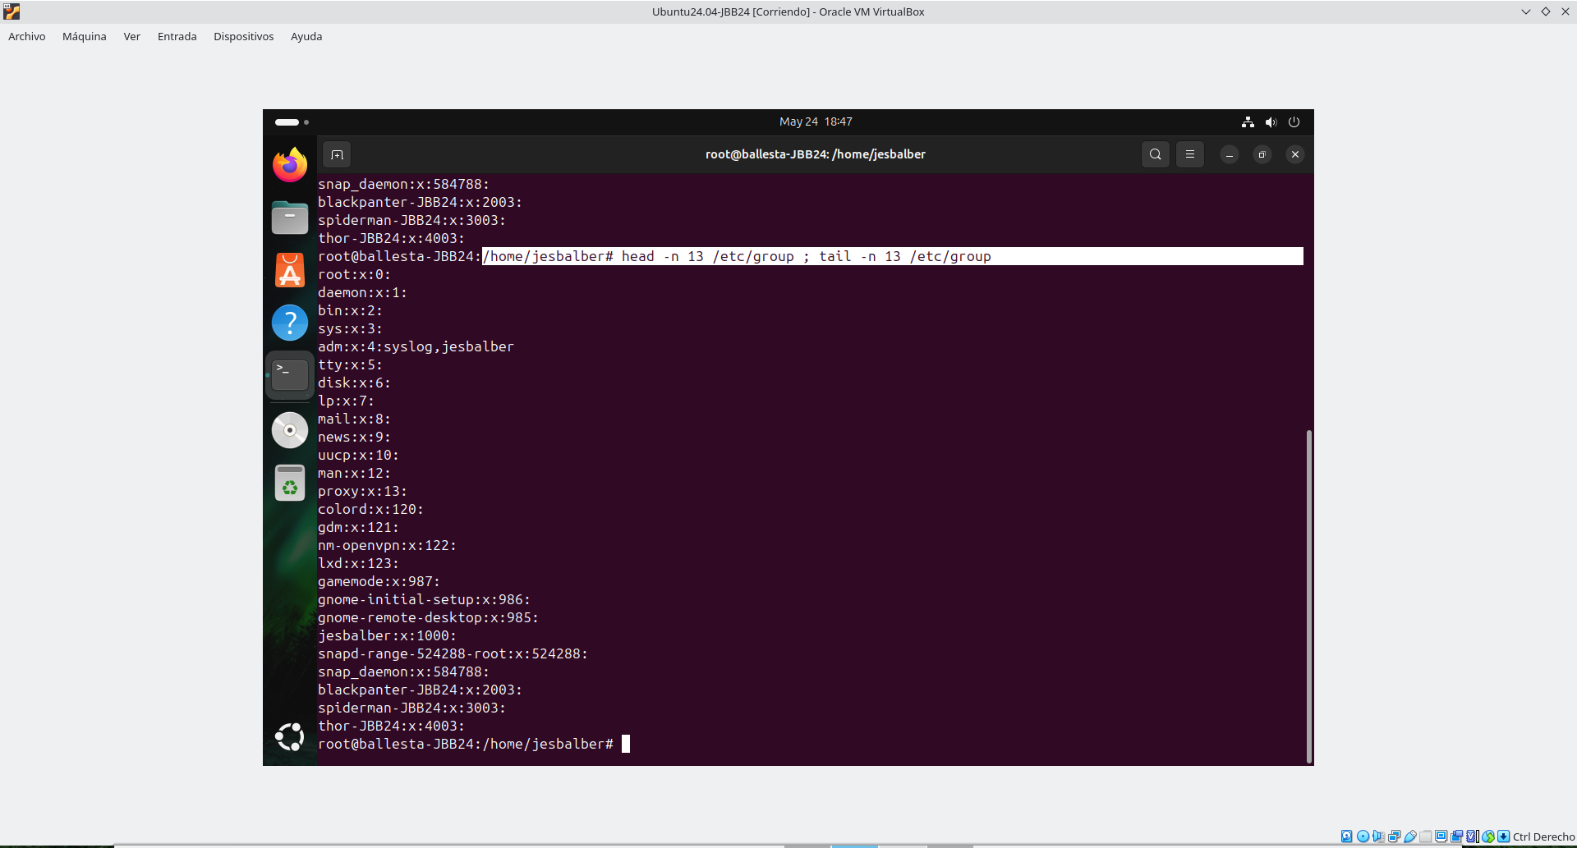

6. With commands create the group heroes-<codId> with the GID (Group Identifier) 5000+<nºPC>.

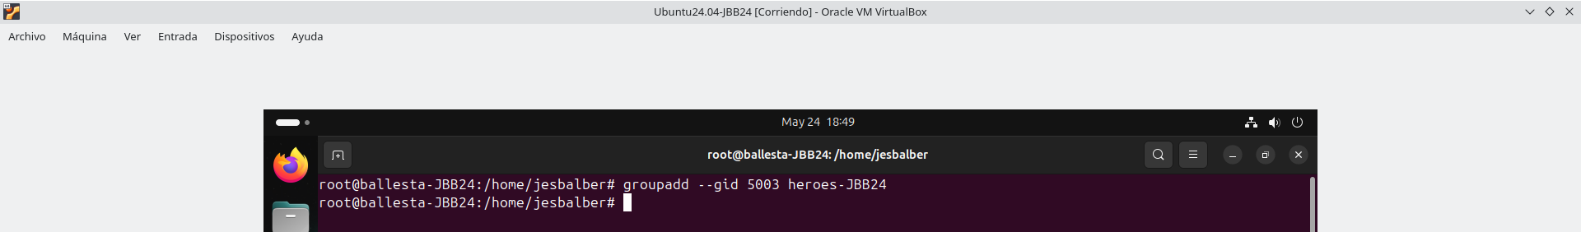
7. With commands add to heroes-<codId> the users: thor-<codId> and spiderman-<codId>.
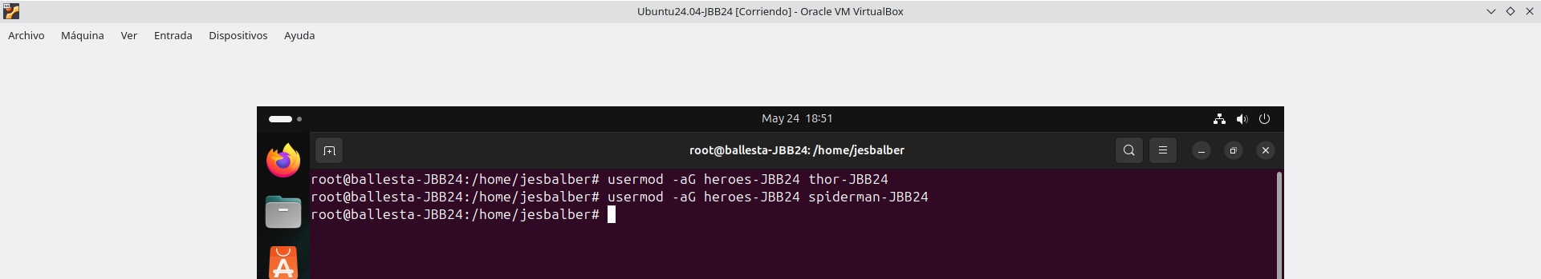

8. Show by using 1 command, only the groups of the user thor<codId>.

9. Show by using 1 command, UID and GIDs of the belonging groups for user thor-<codId>.
10. Run a command to show only lines of the group configuration file with the string thor-<codId>
(use command grep for searching the required lines).
11. Show by using 1 command, UID and GIDs of the belonging groups for user student-<codId>.
12. Get, by using finger command, the information (login, full name, shell, home, and so on) of
user: student-<codId>. Maybe you must install finger previously.

13. Get, by using lslogins command, the login information of user student-<codId>.

14. Get, by using lslogins and who -a command, the login information of all users.

15. Create with webmin a user with login/real name w-<codId>, UID 6000+xx, shell /bin/false,
group grp-<codId>. (xx = <nºPC>).
16. By using chage command, change options of use w-<codId>: account expires on xx of
September, maximum of 1000+xx days between password change, warn 100+xx days in
advance, and can’t change password until xx days. [Screenshot].
17. By using chage command show user account configuration for user w-<codiId>.
[Screenshot].
18. By using 1 command delete user account w-<codId> and its data (home directory and
email). [Screenshot].
19. It is always very useful to know the inner workings of the operating system in order to have a
better control of the operations it performs. Explain the content and meaning of the lines in
the following files:
• /etc/passwd:
• /etc/groups:
• /etc/shadow:
20. For what and when do we use the pwconv and pwunconv commands?

21. Lock out user balckpanter-<codId> by editing file /etc/shadow.

22. Lock out with 2 different commands, users spiderman-<codId> and thor-<codId>.

23. View status of user’s account spiderman-<codId> and blackpanter-<codId> (if it’s locked or unlocked) by using commands.

24. Unlock out user balckpanter-<codId> by editing file /etc/shadow.

25. Unlock out with 2 different commands spiderman-<codld> and thor-<codId>.

26. Create user gui-<codld>, type of user: Desktop user, UID 7000+xx, by using the graphical tool:

27. Sign in a GUI session with gui-<codId>. Next, run commands: cd /, cd $HOME, echo $UID, finger $USER.

28. Sign out with user gui-<codId> with command pkill -u $USER. Next sign in/log on the system (GUI) with the user adm-<initial>.

29. Log on the system (TUI-terminal session) with the user gui-<codId>, with the command used for switch user.

30. Use exit command and next delete user gr-<initial> and its data with a graphical tool.

31. Modify the system security policy so that passwords are valid for 100 days + xx (xx=numberPC) cannot change password within first xx days and warn user 10+xx days earlier. In addition, users and new groups are created from UID and GID, 10000+xx. (Do not use webmin).

2. File systems

2.1. Disk partitions

32. Add 8 new virtual disks of N GiB capacity and reboot the system (the virtual machine). 𝑁 = 2 + (𝑛º𝑃𝐶/4)

33. Reboot the computer, and next use 4 different commands to find out about the new disks [/dev/sdb … /dev/sdi] (logical info).
# fdisk -l
# parted -l
# lshw -C disk
# lsblk -fm

34. With the fdisk command, use the MBR partition system (DOS) create 2 primary partitions of the same capacity=size for using the full capacity of disk, in the last of the free hard disk added (nineth-9th disk=disk 9: /dev/sdi).

# fdisk /dev/sdi
Command (m for help): m
Help:

35. Format both partitions in ext4, and use 2 different commands to set the labels=tags vl-sdi1-<codId> and vl-sdi2-<codId> to the new volumes (formatted partitions) respectively.

36. With commands, respectively mount them on 2 directories that you will create: directories are /media/sdi1-<codId> (first volume) and /media/sdi2-<codId> (second volume).

37. Run “mount” command (with no options) to check out that partitions are properly=correctly mounted.

38. With commands, set all permissions all to users on directories=folders /media/sdi1-<codId> (first volume) and /media/sdi2-<codId> (second volume) and their content (set permissions recursively).

39. Access directories where volumes were mounted, and create a file inside with name<initial>.txt.

40. Run command umount using both the directory and device name for unmounting previous volumes.

41. Run commands to check the filesystem (to fix problems) of both 2 volumes you created on 9th disk.
# fsck /dev/sdi1
# fsck /dev/sdi2

3. RAID

42. Install the package to manage RAID (maybe it’s installed by default). Take a screenshot of the command.

43. With commands, create a RAID 10 with available disks 2,3,4,5,6,7, with chunk (stripe) size of 256 KB.

44. Once created RAID device, use GPT and create 1 volume with ext4 and tag data-<initial>.

45. With commands, add 1 spare disk (with disk number 8: /dev/sdh) to RAID 10.

46. Configure the system so that RAID 10 is automatically mounted on the folder /media/data- <initial> (remember create the folder and set all permissions), and check if it’s works smoothly after booting. The raid will be checked with fsck at start-up. (Watch out!!: raid name
could change from /dev/md0 to /dev/md127 after rebooting, by default)

47. Restart the computer again and check that the RAID system is automatically mounted (run command: mount -av and create folder <initial> inside). Next, show content of file /etc/fstab, and permissions of /media/data-<initial>. Execute a command that display the detailed
RAID configuration that you have just created.

48. Run the df command with the appropriate=proper=suitable options to view the available capacity on all disks, so that you can find out the capacity in M (MiB), G (GIB) or T (TIB), and not only in KB.

49. Carry out a command to display only physical information of devices: hard disk drives, optical drives, etc.

50. Install gparted (storage devices management GUI tool), and run the tool to find out about the RAID device.

4. Disk Quotas

51. Install the package to manage DISK QUOTAS for users and groups.

52. Edit and configure the file /etc/fstab in order to activate user and group quotas in the RAID system.

53. Restart your computer, next run=execute a command to activate both users and group quotas forcedly.

54. Set hard quotas by size xx MB (xx = number PC) user heroes-<initial>, and 10 MB + xx (xx = number PC) user blackpanter-<initial>; and also=besides=what is more=in addition, the number of inodes (or maximum number of files-directories to be created) is 100+xx, for both users.

55. Enter the system with the user spiderman-<initial> and copy files in the directory /media/data-<initial> until you overcome=hit=reach the user disk quota.

56. Assign a soft quota of 100+xx MiB and a hard quota of 500+xx MB, and a hard quota for number of inodes of 1000+x for heroes-<initial> group.

57. Log in as blackpanter-<initial> and copy 10 files in /media/data-<initial>.

58. Change the grace period=time for user quotas to 100+xx days.

59. As root, check out status of the quotas for user: spiderman-<initial> and blackpanter-<initial>.

60. Sign in as root and get a report of all the file systems with quotas by carrying out a command.

61. Disable quotas on /media/data-<initial> with 1 command.

62. Create a new folder with name sales-<initial> into/inside data-<initial> (/media/data-<initial>/sales-<initial>).

63. Set permissions using commands on sales-<initial> folder and its subfolders, so that the user blackpanter-<initial> have all permissions and heroes-<initial> group only has read access=permission (by entering the folder and view its contents), and the other users have
no permissions at all.

64. Carry out two commands to get the list of permissions of folder /media/data-<initial>/sales-
<initial>.

65. Check that you have set permissions correctly by trying out creating both one folder and one file (with commands) on /media/data-<initial>/sales-<initial>. Without logging out, you have to switch to users: blackpanter-<initial>, spiderman-<initial>, student-<initial> and root. Next check the permissions with the 4 different users.

5. System starts and stops

66. Configure GRUB (boot manager/boot loader) in order to: display the menu for 10+xx (xx=number pc) and beep as=when the menu is displayed. Update GRUB, and try booting the GRUB configuration. Take screenshots with settings (edition of grub, update) and after
rebooting (display GRUB menu with the new configuration).

67. Setup GRUB to enter the system without knowing the password, and take the opportunity=chance to change the root password and create a user call grub-<initial>. Take screenshots of the settings=configurations.

68. Run 2 commands to see the current run level, and then run another command with a detailed list of the script that start at that level (for that run level directory)

69. Install the Apache web server with a command, and then start the web server with another command.

70. Run the systemctl command to make Apache service starts (activate=enable) at system start-up.

71. By using a web browser check that the service Apache works correctly=smoothly=properly.

72. Run the service command to stop the running of Apache, and next, with a web browser check if it works.

73. By using webmin check all the services=daemons that are active (start at start-up) in the system, and show information about Apache service (if webmin is not installed, install it previously).

74. Run the systemctl command to get a list of all the services that are active=enable in the system (start at start-up), you can use command: sudo systemctl list-unit-files –state=enabled.

75. Run again systemctl to make Apache service do not start at system start-up, and next, to view its status.

76. Run in a terminal the command nano <initial>.txt.

77. Run in a new terminal one command to=in order to get information of processes with the name: nano.

78. End the process “nano <initial>.txt” forcedly with one command.

79. Run in background the command vi <initial>.txt, and kill not forcedly the process that generates.

80. Create the directory /home/student-<initial>/at-<initial> and copy some files inside.

81. Create bck-<initial> directory on the root (/), in other words, create /bck-<initial>, with all permissions to all.

82. Running with student-<initial> the at command, so that the <initial> directory /home/student-<initial>/at-<initial> is removed in xx minutes (xx = number pc), take screenshots of the execution of the command.

83. Execute a command to see at jobs queue sent for user student-<initial>.

84. Run the at command as root, at xx hours and 30 minutes, stop the Apache service=daemon, and in addition, send all running process information to the file /bck-<iniciales>/ps- <iniciales>.txt.

85. With crontab schedule for every 3 minutes, from Monday to Saturday, to save the date/time in the file /bck-<initial>/d-<initial>.txt (command: sudo date >> /bck-<initial>/d- <initial>.txt). Read file after 10 min.

86. Schedule the system for making a compress backup using the tar command, on Sundays at 23:00+xx minutes (xx = number pc), from January to March, daily from 5 to 25, of /home, on a backup-file called home-<initial>.tgz on the data volume: /media/data-<initial>/home-<initial>.tgz.

87. Run the top tool to view the status of the system while=as running another application.

88. Run command lshw for taking screenshots of specs of: processor, optical drive and network adapter.

89. Try out the dstat command and take a screenshot of its execution (display system statistics).

90. Try out the free command to get the free memory so that you can get it in a suitable=appropriate capacity: KB, GB or TB, and take a screenshot of the execution.

91. Install the tool xosview and take screenshots of both its installation and execution.

92. Install and run iptraf (iptraf-ng) to view network activity while=as downloading a file from the Internet.

93. Examine the /var/log and locate the file in which information about authentications of users in the system is saved. Take a screenshot of the information contained inside.

94. Examine the /var/log and locate the file in which information about installing and uninstalling packages in the system is saved. Take a screenshot of the information contained therein=inside.

95. Execute a command to see the last login of each user. Take a screenshot.

96. Carry out a command to see logins and system shutdowns. Take a screenshot.

97. Compress=Zip your home directory /home/student-<initial> on the file /root/<initial>.tar.gz

98. Access the /tmp directory, unzip the previous file <initial>.tar.gz and check that the data have been extracted=decompressed=unzipped correctly. Where is data decompressed=unzipped and why?

99. Create the source-<initial> and target-<initial> folders on the root directory (/), with all permissions.

100. Copy 3 files in the folder /source-<initial>, and then display its contents with ls -l.

101. Synchronize the folder /source-<initial> (source/origin) on /target-<initial> (destination=target).

102. Check that you have synchronized correctly in the destination=target folder (use command: ls -l).

103. Go to the folder /source-<initial> and remove 2 of the 3 files.

104. Resynchronize the folders so those deleted files are deleted destination, go to the folder /target-<initial> check that you have synchronized correctly, you have also deleted the files in the destination=target folder (use ls -l to see the contents of folders).

105. Create an ISO called /bck-<initial>/<initial>.iso with data from the /etc directory.

106. Execute a command to copy ISO on a CD/DVD drive (take a screenshot of the error).

107. By using dump command make full back up of /root and /home, on file /bck-<initial>/<initial>.dump.

108. By using restore restore /bck-<initial>/<<initial>.dump on /tmp directory and list the restored files.

109. By means of a program like=such as deja-dup back up again the /root and /home directory on /bck-<initial> (create the directory /bck-<initial> previously if not created).

110. Access to the /bck-<initial>, and take a screenshot of the files created by deja-dup.

111. Use Clonezilla to clone the entire=whole hard disk containing the operating system in a new virtual hard disk you with the same size as the operating system disk. Be careful do not lose data! (Then run the fdisk command to verify that the both the original disk and the cloned
disk have the same partitions).

